# DATA STRUCTURES AND ALGORITHMS

# LAB 2

## Zeenia Asr - 382732

**Task 1**

**Code:**

class Flight():

def __init__(self):

self.__flight_number = 0

self.__destination = 0

self.__distance = 0

self.__fuel = 0

def calfuel(self):

if self.__distance <= 1000:

self.__fuel = 500

elif self.__distance <= 2000:

self.__fuel = 1100

else:

self.__fuel = 2200

return self.__fuel

def FEEDINFO(self, num, des, dist):

self.__flight_number = num

self.__destination = des

self.__distance = dist

self.__fuel = self.calfuel()

def SHOWINFO(self):

print(f"Flight number: {self.__flight_number}")

print(f"Destination: '{self.__destination}'")

print(f"Distance: {self.__distance}")

print(f"Fuel: {self.__fuel}")

def main():

obj = Flight()

obj.FEEDINFO("GH888", "Islamabad", 300)

obj.SHOWINFO()

if __name__ == '__main__':

main()

**Output:**

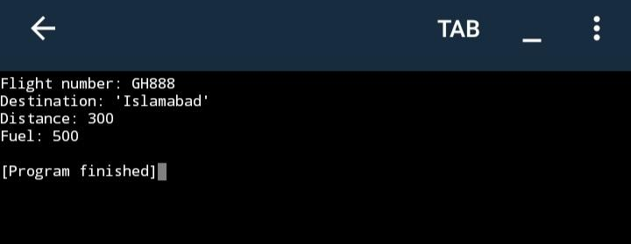

**Task 2**

**Code:**

class Batsman():

def __init__(self):

self.__bcode = "0000"

self.__bname = ""

self.__innings = 0

self.__notout = 0

self.__runs = 0

self.__batavg = 0

def calcavg(self):

return self.__runs / (self.__innings - self.__notout)

def readdata(self, bcode, bname, innings, notout, runs):

self.__bcode = str(bcode)

self.__bname = str(bname)

self.__innings = innings

self.__notout = notout

self.__runs = runs

self.__batavg = self.calcavg()

def __repr__(self):

i = ""

i += f"Bcode: {self.__bcode}\n"

i += f"Batsman: {self.__bname}\n"

i += f"Innings: {self.__innings}\n"

i += f"Notouts: {self.__notout}\n"

i += f"Total runs: {self.__runs}\n"

i += f"Batting average: {self.__batavg}."

return i

def main():

obj = Batsman()

obj.readdata("1780", "Aurangzeb Humayun", 57, 38, 672)

print(obj)

if __name__ == '__main__':

main()

**Output:**

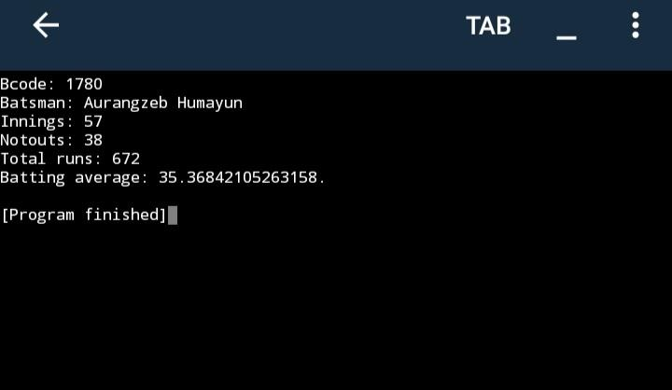

**Task 3:**

**Code:**

class Person():

def __init__(self, name):

self.name = name

self.__state = None

def say(self, stuff):

self.__state = stuff

print(stuff)

return stuff

def ask(self, stuff):

self.say(f"Would you please {stuff}?")

def greet(self):

self.say(f"Hello, my name is {self.name}.")

def repeat(self):

if self.__state is None:

self.say("I squirreled it away before it could catch on fire.")

else:

self.say(self.__state)

def main():

steven = Person("Steven")

steven.repeat()

steven.say("Hello")

steven.repeat()

steven.greet()

steven.repeat()

steven.ask("preserve abstraction barriers")

steven.repeat()

if __name__ == '__main__':

main()

**Output:**



 